Remote Debugging Demo Script

Demo Owner: Jaime Espinosa [jaime@microsoft.com](mailto:jaime@microsoft.com)

# Pre-requisites

1. Use the Azure Powershell. Make sure you have the correct subscription selected in Powershell – for the scripts to work.

Get-AzureSubscription

List the subscriptions available, and shows which the default

Select-AzureSubscription –name “{your subscription name”} –default

Select a current subscription to use (reverts to default after closing PS)

Add-AzureAccount

If the desired subscription is not shown, you can sign into it

1. Have the latest version of Visual Studio 2013 update 4

<http://www.microsoft.com/en-us/download/details.aspx?id=44921>

1. Have the latest version of Azure SDK installed

<http://go.microsoft.com/fwlink/p/?linkid=323510&clcid=0x409>

Setup scripts

These scripts setup a website onto which you can remote debug.

The automation for setting up this demo can be found here:

Additional manual steps to setup a directory:

# Demo Scenario

For this demo the scenario is as follows:

The site owner has a new site redesign contained in the staging slot and wants to connect, watch and debug their new code before swapping with their site to production.

*Note that it is possible to debug a production site, but if the application is stopped or paused the site will not be able to process requests.*

# Demo Preparation

Because remote debugging requires that you compile code, you have to have a local copy of the gdb file.

This presentation starts with creating a new project in visual studio

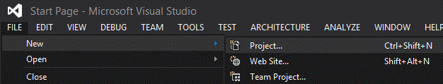

In the “New Project” dialog, search for “Web Form”

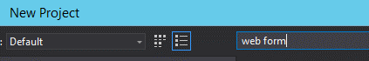

And select an “ASP.NET Web Forms Application”

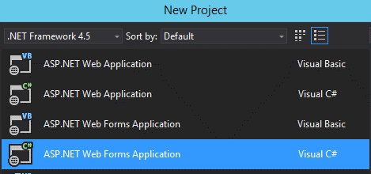

Remote the application insights from this project (to make things faster)

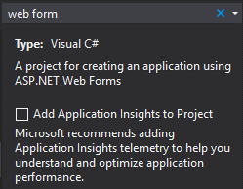

Leave the default name and location (for simplicity) and hit OK

**{{takes 18 seconds to create the project}}**

# Demo steps

From the “Solution Explorer” Right click the “Default.aspx” and choose to view designer

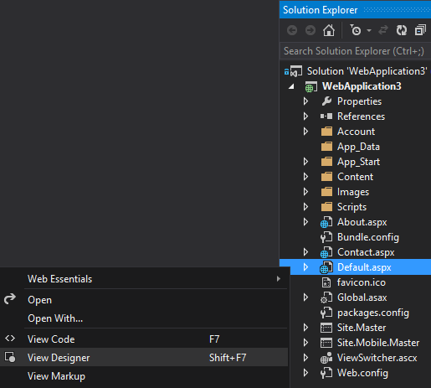

From the *Toolbox* menu, add a button somewhere in the page

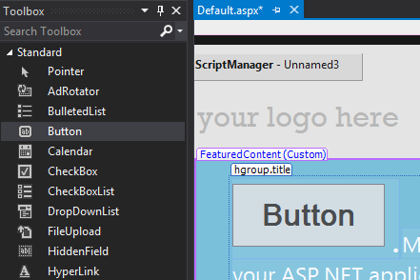

Double click the new Button and it will open the source code file

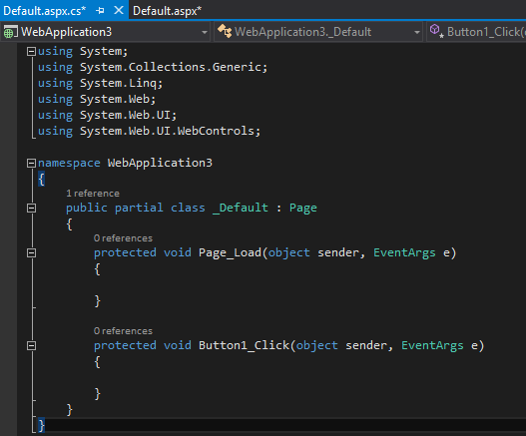

Copy or type the following lines of code

static int i = 0;

protected void Button1_Click(object sender, EventArgs e)

{

string val = i.ToString();

i++;

Button1.Text = val;

}

To look like this:

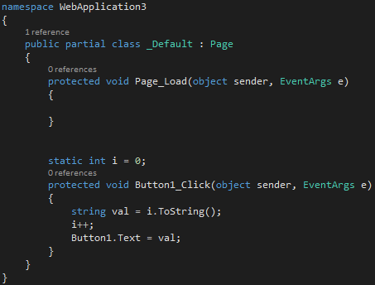

Right click the project and Publish

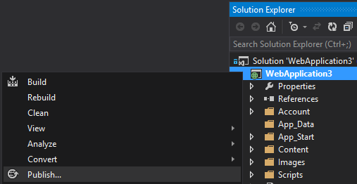

On the publish dialog select Azure Websites ***--------> notice that making a new site at this stage takes less than 1min.***

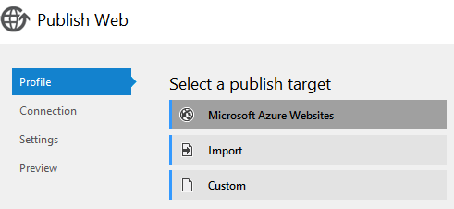

Sign in if need be, and then select a website created by the script (starts with *RemoteDebugDemo* and is the output of the script)

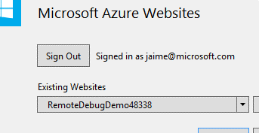

Click Next to go to *Settings*

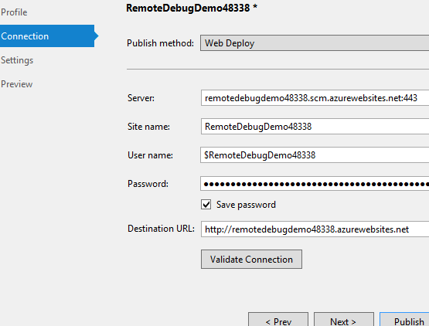

From the *Settings* tab, click the dropdown *Configuration* to select *Debug*

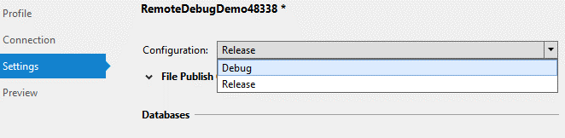

Click *Publish*

**{takes about 10 seconds to publish)**

Now, attach the remote debugger

From the *Server Explorer*, select WebSites and find the *RemoteDebugDemo###*

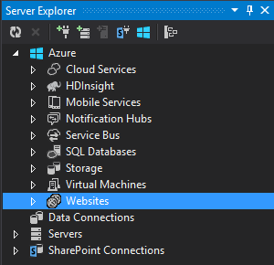

Right click the Website and select *Attach Debugger*

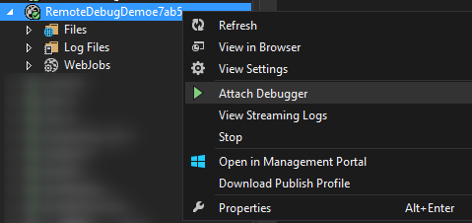

Add a breakpoint to the code

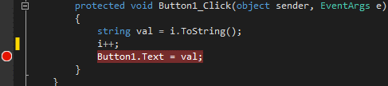

And, click the button on the webpage

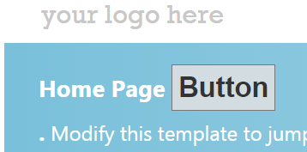

The breakpoint will be hit, pausing the process

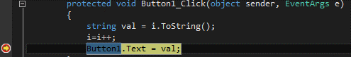

When hovering over the *val* variable pops a box



Click the “0” and make a change



Then select continue (or press F5) to release the process, and go back to the website

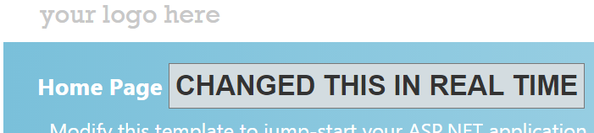

This demonstrates that remote debugging gives you all the debugging power of Visual Studio on code running on the cloud. For more information on the Visual Studio 2013 debugging features, visit <http://msdn.microsoft.com/en-us/library/01xdt7cs.aspx>